Belraetha Ltd
Sales performance and Customer behavior Analysis
A SQL Server-based analysis of historical order data

Prepared by: Oji Gift Kalu Oka
Department: Data Analytics
Tool Used: Microsoft SQL Server
Dataset: Orders.csv
Report date: 4th November 2026

1.Project Overview

Background
You have recently joined Belraetha Ltd. as a Junior Data Analyst. The management team wants to gain a better understanding of the company's sales performance, customer behavior, product profitability, and regional performance using historical order data.
The company has provided you with a transactional dataset named Orders, which has detailed information about customer orders, products, sales, profit, shipping, and geographical locations.
Your responsibility is to use Microsoft SQL Server to analyses the dataset and produce a business report that answers key business questions. Your findings will help management find growth opportunities, improve profitability, and support strategic decision-making.

2.Business Objective
The primary aim of this project is to use SQL to explore and analyses the Orders dataset to uncover meaningful business insights that can improve operational and financial performance.
- Your analysis should focus on:
- Understanding the overall business performance.
- Measuring sales and profitability.
- Evaluating regional performance.
- Identifying profitable products.
- Understanding customer purchasing behavior.
- Discovering high-value transactions.
- Providing actionable business recommendations supported by data.

3.Methodology

Data cleaning and preparation
The orders.csv file was examined to understand its structure and subsequently imported into SQL Server, with appropriate data types assigned to each column. The data validation process confirmed that all columns were accurate, complete, and unique. Therefore, no additional data cleaning was necessary before proceeding with the analysis.

Tool Used
Microsoft SQL Server was used to extract, organize, and analyze the company's sales data.
- The following SQL functions and clauses were applied:
- SELECT
- FROM
- WHERE
- GROUP BY
- ORDER BY
- HAVING
- SUM ()

4. SQL Analysis and Key Findings

4.1 Data overview
Retrieve the first 10 records from the Orders table to understand the dataset structure.
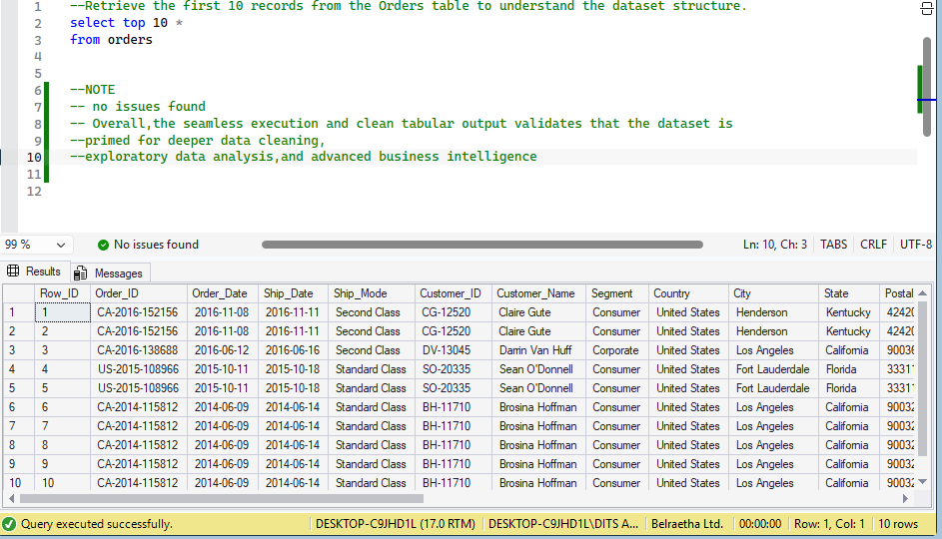
Overall, the seamless execution and clean tabular output validates that the dataset is primed for deeper data cleaning, exploratory data analysis, and advanced business intelligence

4.2 Overall Business Performance
Calculate:
- Total Sales
- Total Profit
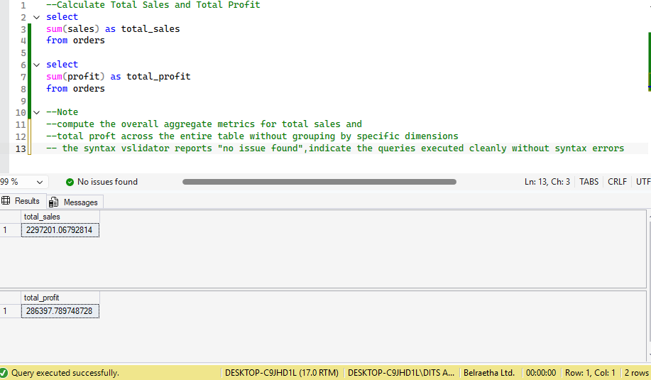
Compute the overall aggregate metrics for total sales and total profit across the entire table without grouping by specific dimensions
the syntax vslidator reports "no issue found”, indicate the queries executed cleanly without syntax errors

4.3 Regional Performance
Determine which region generates the highest total sales.
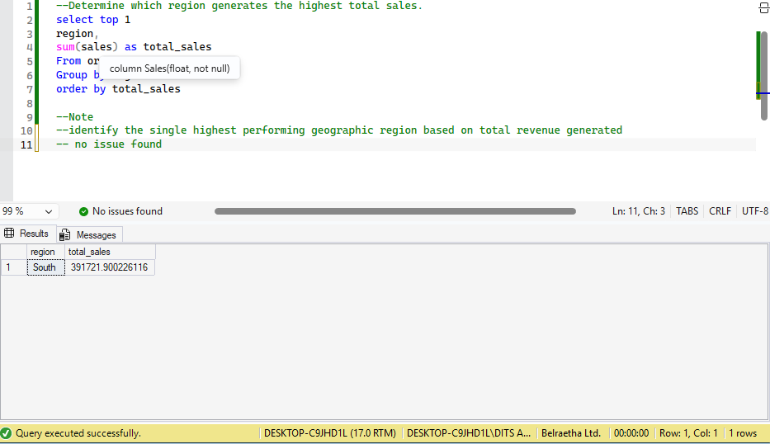
identify the single highest performing geographic region based on total revenue generated, no issue found

4.4 Product Category Performance
Calculate the total sales and total profit for each product category.
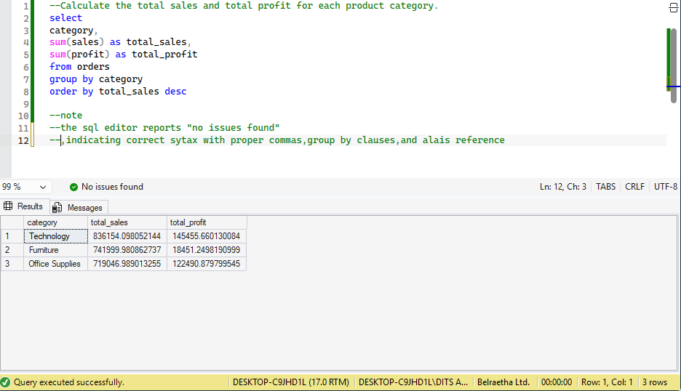
The SQL editor reports "no issues found" indicating correct syntax with proper commas, group by clauses, and Alias reference

4.5 . Customer Segment Analysis
Determine the average sales per order for each customer segment.
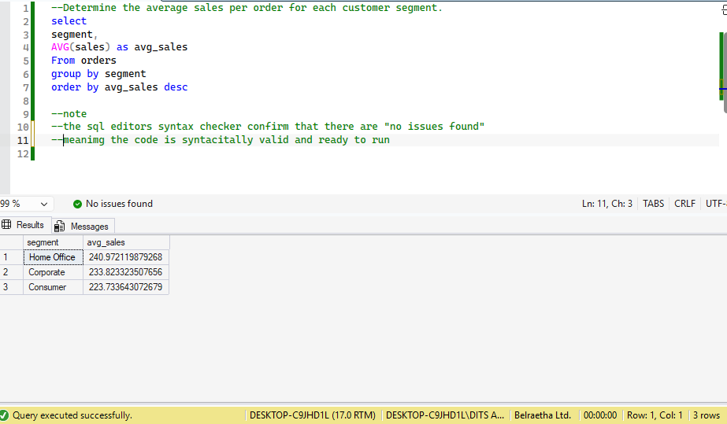
The SQL editor’s syntax checker confirms that there are "no issues found”, meaning the code is syntactically valid and ready to run

4.6 . High-Value Orders
Identify all orders with sales greater than $1,000.
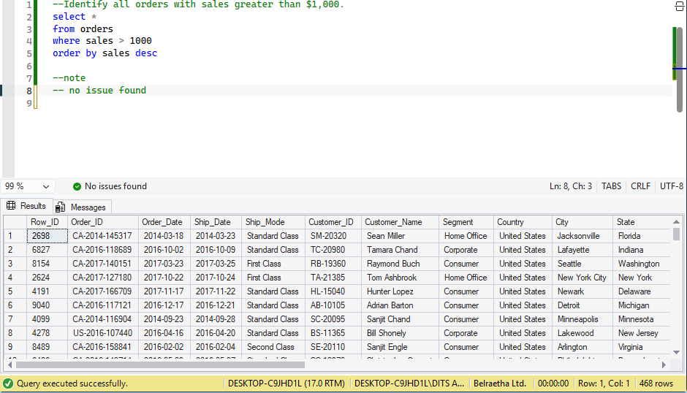
The SQL environment executed seamlessly with zero syntax or runtime errors(“no issues found”).The dataset exhibits a clean relational structure connecting order logistics, customer profiles, geographic regions, and financial metrics

4.7 . Product Profitability
Identify the Top 5 most profitable product sub-categories
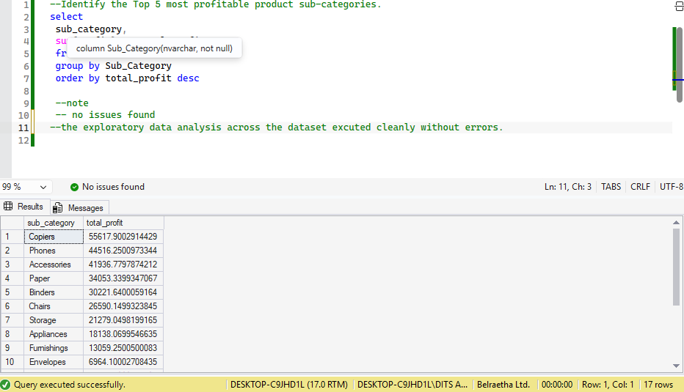
The exploratory data analysis across the dataset executed cleanly without errors.

4.8 Profitability Threshold
Determine which product categories generated more than $10,000 in total profit.
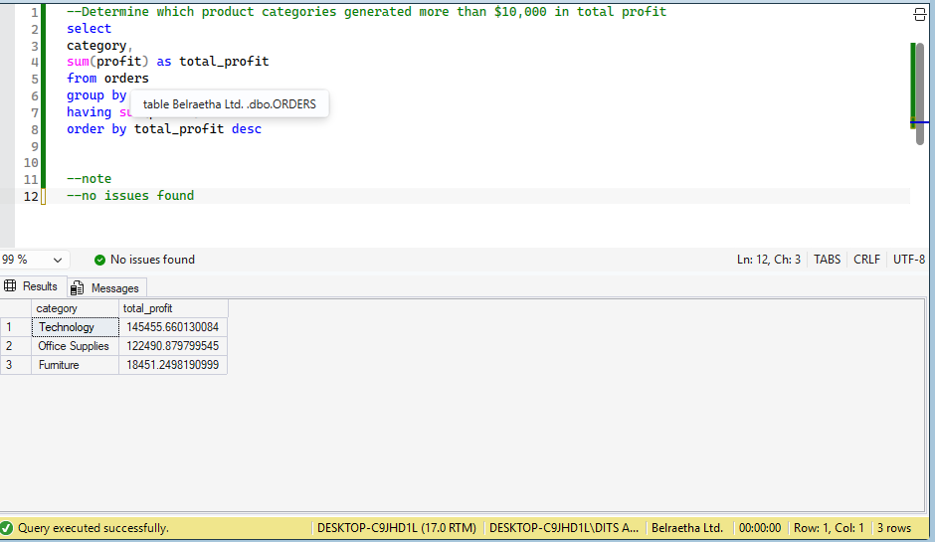
The execution of initial exploration and targeted aggregation queries against the dataset returned complete results with zero execution errors. The system structure spans complete transaction, customer, geographical, and financial for business intelligence modeling.

5.0 Recommendation

1. Key Business Insights & Action Plan
Capitalize on High-Value Buyers (Home Office Segment):
Insight: The Home Office segment drives the highest average sales per order (~$240.97), outperforming Corporate (~$233.82) and Consumer (~$223.73).
Action: Launch targeted bundle offers, bulk pricing, and specialized corporate account management for Home Office clients to maximize revenue per order.
Maximize High-Profit Product Categories (Technology):
Insight: Technology is the single most profitable category overall (~$145,455.66 total profit), led by Copiers (~$55,617.90), Phones (~$44,516.25), and Accessories (~$41,936.78).
Action: Direct marketing expenditure toward Technology sub-categories and secure priority supplier inventory to guard top-line margins.
Fix Profitability Bottlenecks (Furniture):
Insight: Despite high sales volume (~$741,999.98 total sales), Furniture generates disproportionately low total profit (~$18,451.25).
Action: Audit freight costs, logistics fees, vendor pricing, and promotional discount thresholds across Furniture products to protect bottom-line profitability.
2. Technical & SQL Query Optimizations
Enforce Top-N Filtering (⁠TOP⁠ / ⁠LIMIT⁠ Clause):
Issue: The query designed to "Identify the Top 5 most profitable product sub-categories" sorts results descending but lacks a row limit filter.
Fix: Add ⁠TOP 5⁠ (SQL Server) or ⁠LIMIT 5⁠ (PostgreSQL/MySQL) to retrieve only the top 5 records:
Standardize Identifiers & Aliases:
Issue: Minor inconsistencies exist in column capitalization (e.g., ⁠Category⁠ vs ⁠category⁠) and aliasing across ⁠SELECT⁠, ⁠GROUP BY⁠, and ⁠ORDER BY⁠ clauses.
Fix: Maintain strict naming conventions across all script files for query maintainability and execution reliability.

